NYU TANDON SCHOOL OF ENGINEERING

SP SPORTS

Final Doc

By:

Roberto Estrada

Senior Design 2018

Abstract

SP Sports is a sports news and blogging website where people get to engage on debates about sports such as basketball, soccer, American football, golf, etc. The main objective of this website is to get as many people involved in the blogging system. The blogging system will be based on

a 15 seconds limit video about a sport topic where viewers will be able to commentate on it through an upload video system. Normally, companies such as Facebook, Snapchat, and Instagram have this system; however, they do not focus entirely on sports. No other sports website has this type of social network platform. The goal is to add as much statistics possible while keeping the main focus which is the blogging part. In addition, adding a API from CBS Sports can enhance the credibility of the stats represented on SP Sports. For the final presentation, I want to present a compilations of videos through the blogging system. Furthermore, I would want to create a survey where people get to go through the SP Sports experience where they give as much feedback possible. It is a website that will eventually integrate other aspects where ads and raffles will generate a source of income. SP Sport will start as a free website but will transform into a semi-E-commerce website.

Project Statement & Goal

As stablished before, SP Sports is a sports news and blogging website where people get to engage on debates about sports such as basketball, soccer, American football, golf, etc. Goals:

- Develop efficiently the “upload video” content.

- Choose the right API in order to create credibility

- Update sports news everyday; at least twice a day in order to keep viewers interested.

- Create a guided survey that allows me to gather as much feedback in order to correct all deficiencies.

Progress

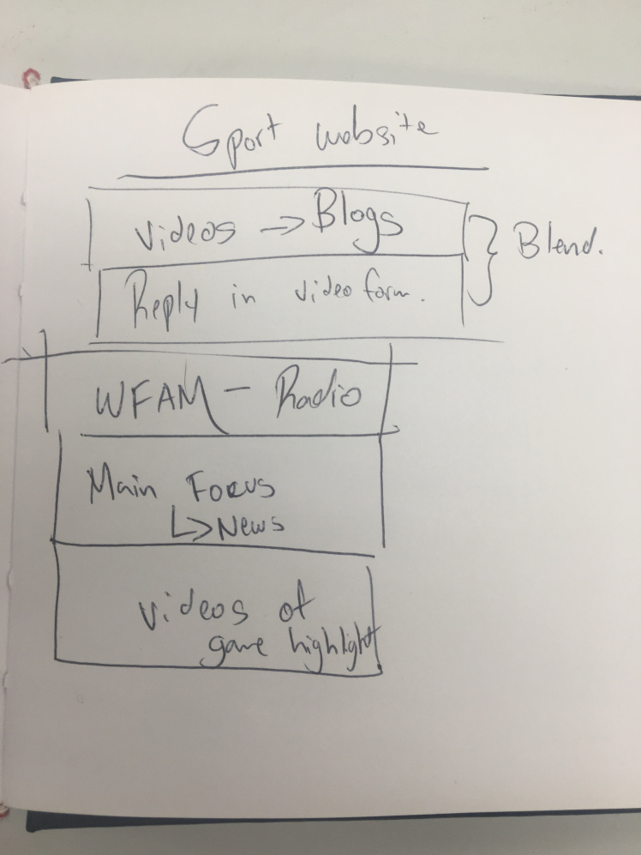

First Iteration

Second iteration



Continues Iterations

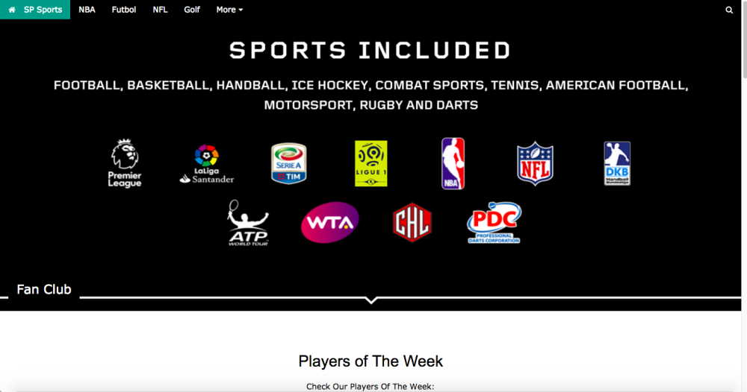

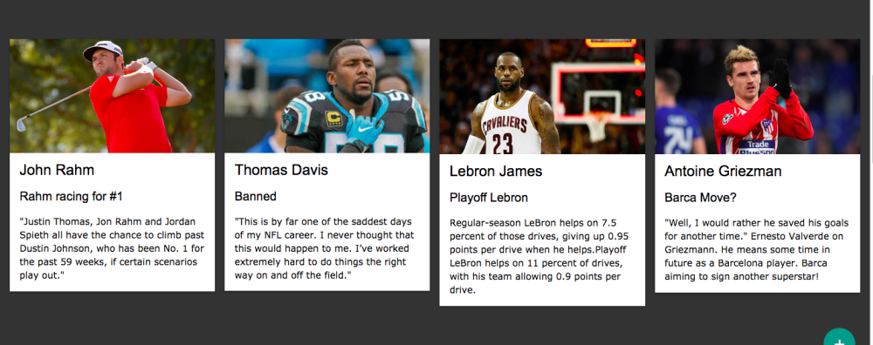

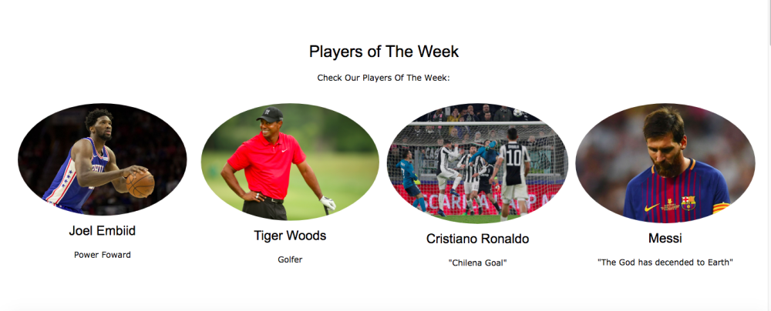

My Work

How can I transmit my thoughts to a website that publishes sport news? How can I make my website better than all other sport websites better? What makes me so passionate about sports? Why do I love sports? Are sport news reliable?

Inspirations

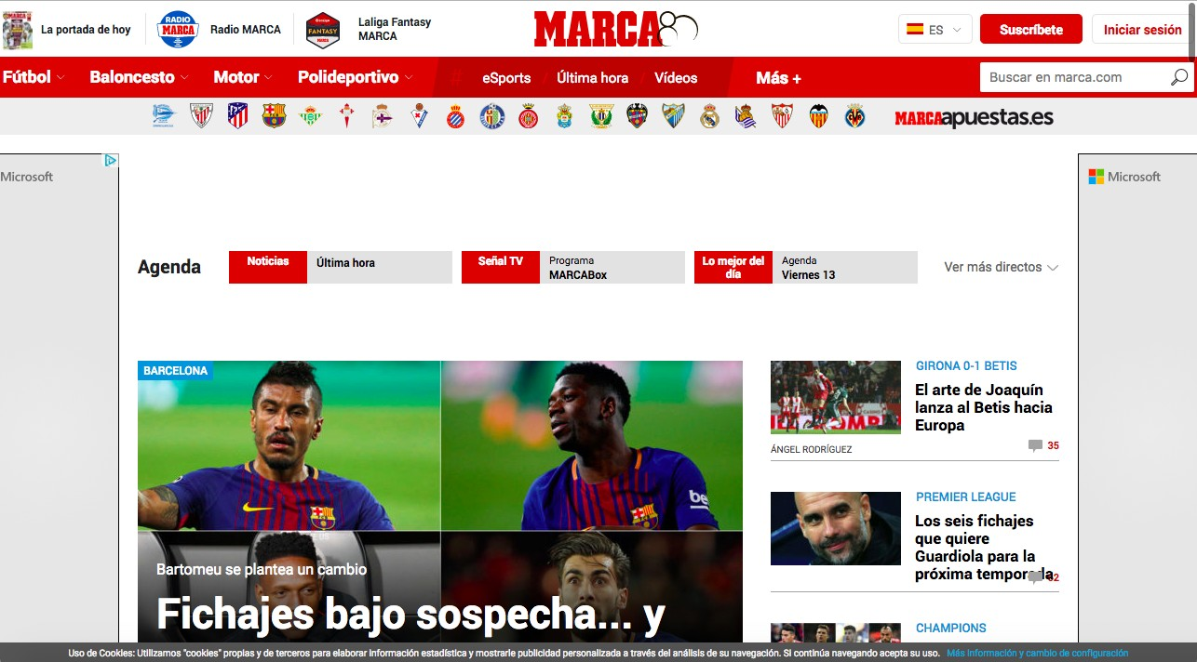

As a constant sports website reader, I got all my inspirations from these two websites and this book. I read Marca and As everyday which allows me to explore market gaps. In addition, the book “Soccer Man” has allowed me have a media perspective over sports. Kuper explores the ideals of players and how



they are affected by newsletters and critics.

Methods

I am using HTML/JAVASCRIPT to develop this project. Following my own guidelines, forming a code using java-script/css is essential. The application I am writing my code is Brackets. If anything else changes, whether I have to use some other language, I will make the right changes accordingly.

Outline

- Brackets

- HTML/CSS

- JAVASCRIPT

- API’S

- Upload system

- Bootstrap

Bibliography

Liang, Daniel (2013) You can use a text editor, such as the Windows Notepad or WordPad, to create Java programs and to compile and run the programs from the command window. You can also use a Java development tool, such as NetBeans or Eclipse. (Page 8)

This book basically represents the beginners guide of Java coding. It shows concepts of problem-solving and object-oriented programming using a fundamentals-first approach. Beginning programmers learn critical problem-solving techniques then move on to grasp the key concepts of object-oriented, GUI programming, advanced GUI and Web programming using Java. The author (Liang) approaches Java GUI programming using JavaFX, not only because JavaFX is much simpler for new Java programmers to learn and use but because it has replaced Swing as the new GUI tool for developing cross platform-rich Internet applications on desktop computers, on hand-held devices, and on

the Web.

Kouper, Simon (2011) From the 1960s, when media attention for players began to grow (see Football Man), until the 1990s, when television money began to flood the game, the profession that soccer soccer resembled most closely was rock music. (page 60)

This chapter talks about Kouper’s experiences in the sport industry and how everything has been changing from the old days to present time. In addition, he argues about the influence of media and news in present day sports. As a journalist, he understands that views will change over time and that people like to write their own opinion of current situations of players and sports. Especially if they are as egocentric as players such as Cristiano Ronaldo and Ibrahimovic. Shabbir (2014); Bootstrapping E-Commerce: https://bootstrappingecommerce.com/html-cssecommerce/

“If you own an ecommerce store(or are planning to in the future) and you don’t have much experience with coding or design, you know that one of the biggest hassles we face is making design changes to our websites.”

This website allows me to see samples of websites that apply an e-commerce feature. In addition, it helps have a better understanding how to code in a more efficient way. Also, it offers a selection of parameters to follow through coding.

Ostrofksy, Marc (2011), Get Rich Click!: Amazon has been called a disruptive force in the publishing industry, contributing to the demise of traditional bookselling practices. But many independent booksellers and small publishers have stayed in business and done well. They’ve developed their own direct Internet sales approaches and have successfully implemented their own websites.

This book allowed me to have a better understanding of multiple strategic plans that work through E-commerce. E-Commerce is such a complex feature that websites struggle to execute properly. Amazon was able to successfully transcend E-commerce into a new phase of technological advancements. I will use this book to follow guidelines and strategies used by other companies to avoid any obstacles with my websites.

Duckett, John (2011), HTML & CSS: Design and Build Web Sites: Introduces HTML and CSS in a way that makes them accessible to everyone—hobbyists, students, and professionals—and it’s full-color throughout. Utilizes information graphics and lifestyle photography to explain. The topics in a simple way that is engaging. Boasts a unique structure that allows you to progress through the chapters from beginning to end or just dip into topics of particular interest at your leisure.

This is probably the most important book I will use for my senior design. It contains all the guidelines needed in order to develop the website envisioned. I will be able to use this book to correct any errors throughout the coding process.